MS WORD 2007

Welcome to the “new world” of Microsoft 2007 Office. Microsoft Word is a word processing software package As you may have heard, 2007 Office is a major change from previous Office versions. You can use it to type letters, reports, and other documents. It gives you the ablilty to use your home computer as well as your business computer for desktop publishing.

AIM:- To familiarize with Ribbon Layout of MS Word 2007

The Home Tab
The home tab the basic formatting tools found in Word 2007. You will find seven sections, Clipboard, Font, Alignment, paragraph, Styles, and Editing. Clicking the down arrow beside any of the icons here will drop down more options for that tool. Each section also contains an arrow in the bottom right corner which will open a window containing the options found in that section.

Insert Tab
The insert tab has five sections for inserting most types of objects. The sections are pages, tables, illustrations, links, header & footer, text and symbols.

Page Layout Tab
The page layout tab has five sections, Themes, Page Setup, page background, paragraph and Arrange.

Reference Tab
The Reference tab has six sections. they are table of contents, Footnotes, Citations & Bibliography, Captions, Index and Table of Authorities

Mailings
The Mailings tab has five sections i.e Create, Start Mail merge, write & insert Fields, Preview Results and Finish.

Review Tab
The review tab offers three sections which include proofing, comments, Tracking , changes and protect

View Tab
The view tab offers five sections which include Document views, show/hide, zoom, window and macros.

Components of MS Word
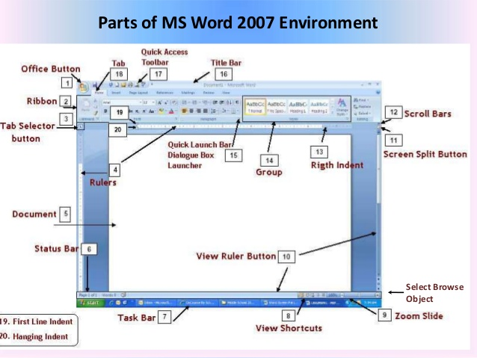

- AIM:- To practice word processing basics in MS- Word 2007
MS-Word is used to create powerful documents to do so one should know and understand the usage of keyboard, mouse and at least some features of MS-Word
Keyboard: it is primary text input device it contains certain standard functions keys, cursor movement keys, shift ant control key etc.
Mouse: it is another input device used to point, select and navigate the text. Click used to select on items double click used to open application. right click to open context menu. Scroll button is used to move to the pages
Practice cut, copy and paste.
CUT:- Remove selected item/text
COPY: Stores the selected text/item temporarily in the buffer area.
PASTE: insert the text/item from buffer area. Where the cursor insertion pointer is placed.
Method for used to apply Cut
Method1: Type some text and select the text. Click on Home Tab then click on cut symbol
Method2: Type some text and select the text. Right Click on the text then click on cut
Method3: Type some text and select the text. Press Ctrl +X
Method for used to apply Copy
Method1: Type some text and select the text. Click on Home Tab then click on copy symbol
Method2: Type some text and select the text. Right Click on the text then click on copy
Method3: Type some text and select the text. Press Ctrl +C
Method for used to apply Paste
Method1: Type some text and select the text. Click on Home Tab then click on paste symbol
Method2: Type some text and select the text. Right Click on the text then click on paste
Method3: Type some text and select the text. Press Ctrl +V
To check the spelling and grammar
Select text from the document then click on review then click on spelling & grammar from proofing group
To Use find and Replace
Open the document and click on Home tab click Find and replace From the editing group
Keyboard short cuts for word Processing
Ctrl + N -------> To open a new document
Ctrl + B -------> To bold the text in a document
Ctrl + I -------> To italic the text in a document
Ctrl + U -------> To underline the text in a document
Ctrl + X -------> To Cut the text in a document
Ctrl + C -------> To copy the text in a document
Ctrl + V -------> To paste the text in a document
Ctrl + Z -------> To undo the process in a document
Ctrl + P -------> To print the document
Ctrl + O -------> To open a existing document
Ctrl + F -------> To find the text in a document
Ctrl + H -------> To replace the text in a document
Ctrl + K -------> To open Hyper link in a document
Ctrl + S -------> To save the document

- AIM:- To practice Formatting Techniques in MS- word 2007
Formatting text can be emphasize your document for adjust the font of the text, font size, font color and insert special symbols and also adjust the alignment of the text like numbering, bullets etc
Procedure:-
- Click on Start Button
- Click on All Programs
- Select MS office and click on Ms word
- Point the cursor in the Ms word
- Type the text using keyboard
- Save the file
To change the font style
Select text click on Home tab then click on drop down menu of font style then change the style of the text
To change the font size
Select text click on Home tab then click on drop down menu of font size then change the size of the text
To change the font color
Select text click on Home tab then click on drop down menu of font color then change color of the text
To Apply Bold ,Italic, Underline to the text
Select text from the document then click on Home tab then
Click “B” For Bold the Text
Click “I” For Italic the Text
Click “U” For Underline the Text
To change the Text Case (uppercase, lowercase)
Select text from the document then click on Home tab then click on change case
To change the Text Alignment
Select text from the document then click on Home tab then click on Alignment button
For arranging the text as left Alignment, Right Alignment and Center Alignment
To Formatting paragraph
Select paragraph from the document then click on Home tab then choose alignments from praragraph group
To inserting page numbers header and footer
Select the document then click on insert select header and footer and insert header /footer to the document

- AIM:- To Insert a Table required Number of rows and columns in MS WORD 2007

Procedure:-
- Click on Start Button
- Click on All Programs
- Select MS office and click on Ms word
- Point the cursor in the Ms word
- Click on insert Button
- Select table
- Click insert table from dropdown menu of table
- Select no. of rows and columns
- click ok
- Click on office button from top left corner of the window and save the document
- Close the document by clicking on close button from top right corner of the window

Example: table with 2 Rows & 3 Columns

- AIM:- To Insert an object, clipart and Hyperlinks in MS- Word 2007
Procedure:-
- Click on Start Button
- Click on All Programs
- Select MS office and click on MS WORD 2007
- Click on insert and click on picture
- window will be open then
- Select picture from window dialog box
- click ok
- Click on office button from top left corner of the window and save the document
- Close the document by clicking on close button from top right corner of the window

Example:  

To Insert Hyperlink in MS WORD 2007
- Click on Start Button
- Click on All Programs
- Select ms office and click on MS WORD 2007
- Type the text in MS WORD 2007
- Select the text
- Click on insert Button
- click on Hyperlink and select Destination file or folder that can open with the Link
- click ok
- selected text appear as underline text
- if you want to open the Link Press CTRL+ Click to follow Link
- Click on office button from top left corner of the window and save the document
- Close the document by clicking on close button from top right corner of the window

Example of Hyperlink: CLICK

- AIM:- Mail Merge features of MS word 2007
A function that allows the user to insert information from a database into form letters, envelopes, and other mass mailings
Procedure:-
On the Ribbon, select the Mailings tab > in the Start Mail Merge group > click Start Mail Merge
Select, “Step by Step Mail Merge Wizard…”
A column to the left of the screen should appear which displays choices for different document types
- Step 1 – Select document type
Select the radio button for, “Letters”
At the bottom of the column under “Step 1 of 6” select, “Next: Starting Document”
- Step 2 – Starting Document
Under “Select starting document” select the radio button for “Use the current document”
At the bottom of the column under “Step 2 of 6” select, “Next: Select recipients”
- Step 3 – Select Recipients
Under “Select recipients” select the radio button for “Type a new list”
Under “Type a new list” select “Create…”New Address List
In the New Address List window there are many fields provided as a default
To modify the fields select the “Customize Columns…” button Create records
Enter fictitious record values for: First Name, Last Name, Address Line 1, City, State, Zip Code
Click inside the box and type in data
When finished with the first record select the “New Entry” button in the bottom and type another record .Enter three records total Select the OK button
Save the Address List Save the file in the default location, My Data Sources
Save the file name as, “word_3.mdb”
- Step 4 – Write Your Letter
In the Mail Merge column to the right, under “Write your letter” select “Address block…”
Go through and choose which options work for your address block Select the OK button
In the Mail Merge column to the right, under “Write your letter” select “Greeting Line…”
- Step 5 – Preview your letters
Notice that in the Ribbon the Preview Results button is selected
Use the arrow button in the same section (or in the Mail Merge column to the right) to preview the document with other recipient information
At the bottom of the column under “Step 5 of 6” select, “Complete the merge”
- Step 6 – Complete the merge
If you wanted to print the document then you would choose, “Print…” in the Mail Merge column to the right

- AIM:- To use equations and symbols in MS Word 2007

Procedure:-

- Click on Start Button
- Click on All Programs
- Select Ms office and click on MS WORD 2007
- Type the text in MS WORD 2007
- Select the text
- Click on insert Button
- From the Insert tab click on equation and symbols
- Select equation and symbols
- Insert equation and symbols
- Click on office button from top left corner of the window and save the document
- Close the document by clicking on close button from top right corner of the window

Examples
Equations:
1. $A=πr^{2}$
2. $x=\frac{-b±\sqrt{b^{2}-4ac}}{2a}$
Symbols: € £ ¥ ∑ β ∞ µ

MS-EXCEL- 2007
What is Microsoft Excel?
Microsoft Excel is a spreadsheet application program offered in the Microsoft office software package. This program allows you to perform calculations and use graphic tools, pivot tables, and a macro programming language called VBA. In addition, Excel can also be used to create charts and graphs
Starting Excel: 1. Go to the Start Button on the Desktop and press it. Click on All Programs. 2. Then click on Microsoft Office, then Microsoft Office Excel 2007. 3. This opens the Excel 2007 program.
In the top left corner of the screen, the Office Button appears. Use this to Open or Print your files. To the right of this is the Quick Access Toolbar, which only has three buttons on it by default – Save, Undo and Redo. To add extra buttons, click on the down arrow on the right and choose Customize Quick Access Toolbar. As you can see here the Office logo opens up listing your options for new, open, save, save as , Print, etc
- AIM:- To familiarize with Ribbon Layout of MS Excel 2007

The Home Tab
The home tab the basic formatting tools found in Excel 2007. You will find seven sections, Clipboard, Font, Alignment, Number, Styles, Cells and Editing. Clicking the down arrow beside any of the icons here will drop down more options for that tool. Each section also contains an arrow in the bottom right corner which will open a window containing the options found in that section.

Insert Tab
The insert tab has five sections for inserting most types of objects. The sections are tables, illustrations, charts, links, text and symbols.

Page Layout Tab
The page layout tab has five sections, Themes, Page Setup, Scale to Fit, Sheet Options, and Arrange.

Formulas Tab
The formulas tab contains four sections, function library, defined names, formula auditing and calculation.

Data Tab
The data tab contains five sections; get external data, connections, sort and filter, data tools, and outline.

Review Tab
The review tab offers three sections which include proofing, comments, and changes

View Tab
The view tab offers five sections which include workbook views, show/hide, zoom, window and macros.

Components of MS Excel 2007
Sort & Filter button

Wrap Text button
Home tab
Sum button
Undo
button
Save button
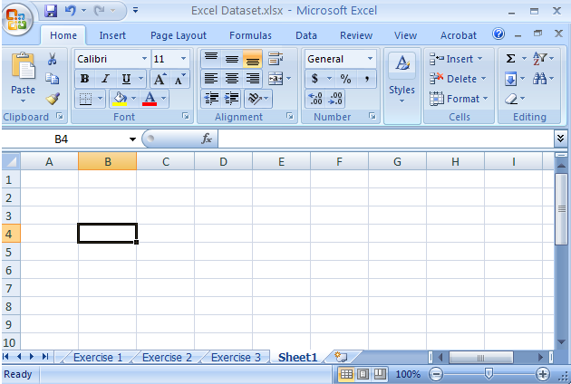
Quick Access toolbar
Function button
Name Box
Office button
Merge button
Columns
Select All button
Rows
Formula Bar
Worksheets
Scroll bars

- AIM:- To access and enter data in the cells in MS-Excel 2007
Procedure:-

- Click on Start Button
- Click on All Programs
- Select Ms office and click on MS Excel 2007
- Excel sheet will be open with rows and columns called cell
- Point the cursor on the cell and Enter data in the cell
- Click on office button from top left corner of the window and save the document
- Close the document by clicking on close button from top right corner of the window
Example:
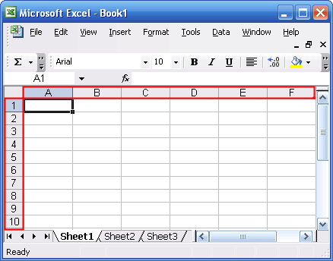

- AIM:- To edit a spread sheet copy, cut, paste in MS Excel 2007
Edit: If at any time you need to edit the contents of a cell, click in that cell, then press the Edit key (F2 at the top of your keyboard). You can also edit double-click in the cell or click in the cell then on the formula bar, then make changes.
Delete/Clear: To delete the contents of a cell or range of cells, select the cell(s) then press the delete key. An alternate is to select the cell(s), then click on the icon in the editing Group on the Home ribbon. Your options on the Clear icon .
Procedure:-
- Click on Start Button
- Click on All Programs
- Select Ms office and click on MS Excel 2007
- Excel sheet will be open with rows and columns called cell
- Point the cursor on the cell and Enter data in the cell
- Select the data from the sheet to copy, cut and paste
- From Home tab click on copy or cut or paste
Or
- Select the data from the sheet and right click on the data then select cut, copy and paste
Or
- Select the data from the sheet For cut press CTRL + X, For Copy CTRL + C and For Paste CTRL+ V

- AIM:-. To use built in functions and formatting data in MS Excel 2007
Procedure:-
- Click on Start Button
- Click on All Programs
- Select Ms office and click on MS Excel 2007
- Excel sheet will be open with rows and columns called cell
- Point the cursor on the cell and Enter data in the cell
Built in functions Like Sorting And Filtering
For Sorting the Data
- Create a sheet in Excel like Department, Name of Employee , Designation and District
- Select the data from the sheet to perform sorting Technique
- Click on Data then Click on Sorting i.e Ascending or Descending
Filtering the Data: Filtered data displays only the rows that meet criteria (criteria: Conditions you specify to limit which records are included in the result set of a query or filter.) that you specify and hides rows that you do not want displayed. After you filter data, you can copy, find, edit, format, chart, and print.
- Create a sheet in Excel like Department, Name of Employee , Designation and District with a column heading
- Select the data from the sheet to perform Filter Technique
- Click on Data then Click on Filter
- After applying Filter click on drop down Arrow on the cell and then select particular data from the sheet
Formatting data in the Excel sheet are Cell Alignment, Text Alignment, font Style, Font size ,Font color etc
- Select the cells from the Excel sheet and click on Home Tab Then Click on Alignment like left, right, top, center etc
- Select the cells from the Excel sheet and click on Home Tab Then click on Font and change the style, size ,color etc
- Select the cells from the Excel sheet and click on Home Tab Then Click on Alignment click on merge & center command for merging and centering the text
- Select the cells from the Excel sheet and click on Home Tab Then Click on cell Tab for inserting, deleting and format

Example: Sorting Data Filter Data
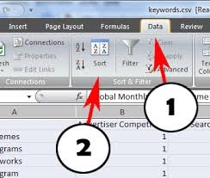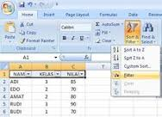

- AIM:-. To create Excel Functions , Filling cells in MS Excel 2007
Procedure:-
- Click on Start Button
- Click on All Programs
- Select Ms office and click on MS Excel 2007
- Excel sheet will be open with rows and columns called cell
- Point the cursor on the cell and Enter data in the cell. Example: create student mark sheet
- Select the cell where the answer will appear
- Then type equal sign(=) then enter function name (Sum, count, Max, Min etc)
Example : 1. “=SUM(C4,C5,C6)” then press Enter or
Example : 2. “=SUM(C4:C6)” then press Enter
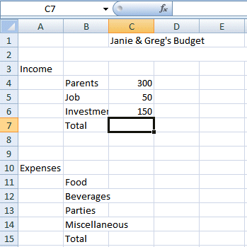

Filling cells: The fill handle is in the bottom right hand corner of the cell. When you move the mouse to that corner, the pointer changes to a black plus sign. Hold the left mouse button down and drag through the cell that you want to copy the formula to. Auto fill is a feature used to fill a range of cells with some values.
Procedure:-
- Click on Start Button
- Click on All Programs
- Select Ms office and click on MS Excel 2007
- Excel sheet will be open with rows and columns called cell
- Some values may be filled in the cells type one value and drag the fill handle
- Type the word in the first cell of the range
- Select cell and fill content either vertically or Horizontally
- Position your mouse over the fill handle so the white plus sign becomes a black plus sign
- Click and drag the fill handle over the required range
- Click on office button from top left corner of the window and save the document
- Close the document by clicking on close button from top right corner of the window
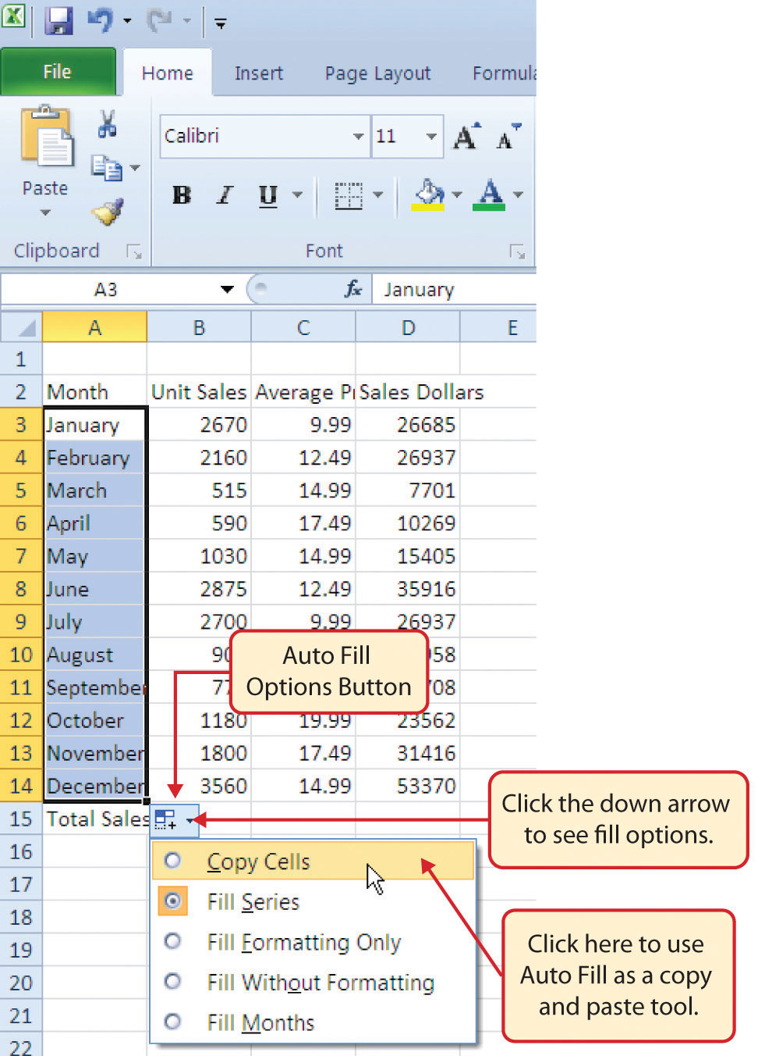

- AIM:- To Enter a formula for Automatic calculations in MS Excel 2007

Procedure:-
- Click on Start Button
- Click on All Programs
- Select Ms office and click on MS Excel 2007
- Excel sheet will be open with rows and columns called cell
- Point the cursor on the cell and Enter data in the cell. Example: create student mark sheet
- Select the data from the sheet to perform calculations
- Click on Home Tab and then click on “ ∑ “ symbol for automatic calculations like Sum, Average maximum, minimum etc
- Click on office button from top left corner of the window and save the document
- Close the document by clicking on close button from top right corner of the window
Example:

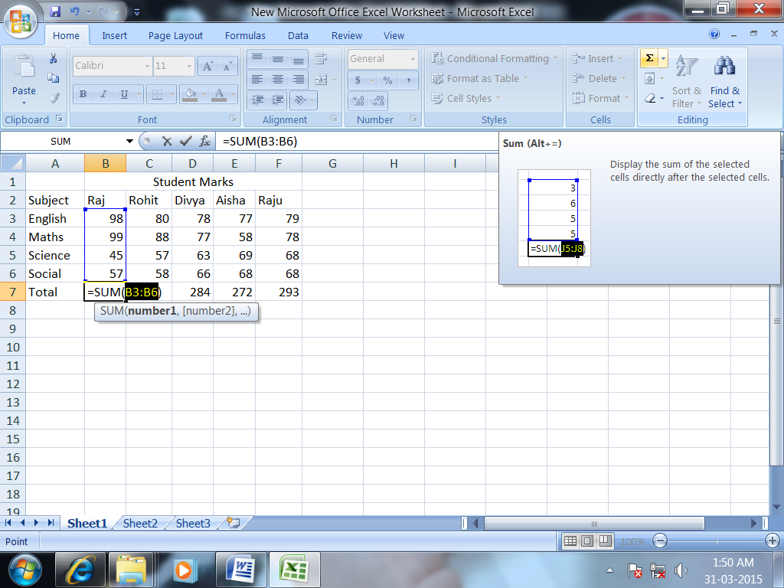

- Aim:-To Practice Excel Graphs and Charts in MS Excel 2007
Procedure:-
- Click on Start Button
- Click on All Programs
- Select Ms office and click on MS Excel 2007
- Excel sheet will be open with rows and columns called cell
- Point the cursor on the cell and Enter data in the cell. Example: create student mark sheet
- Select the data from the sheet to create charts
- Click on insert Tab and then click on charts like column ,pie ,bar charts etc
- Click on office button from top left corner of the window and save the document
- Close the document by clicking on close button from top right corner of the window
Example chart:
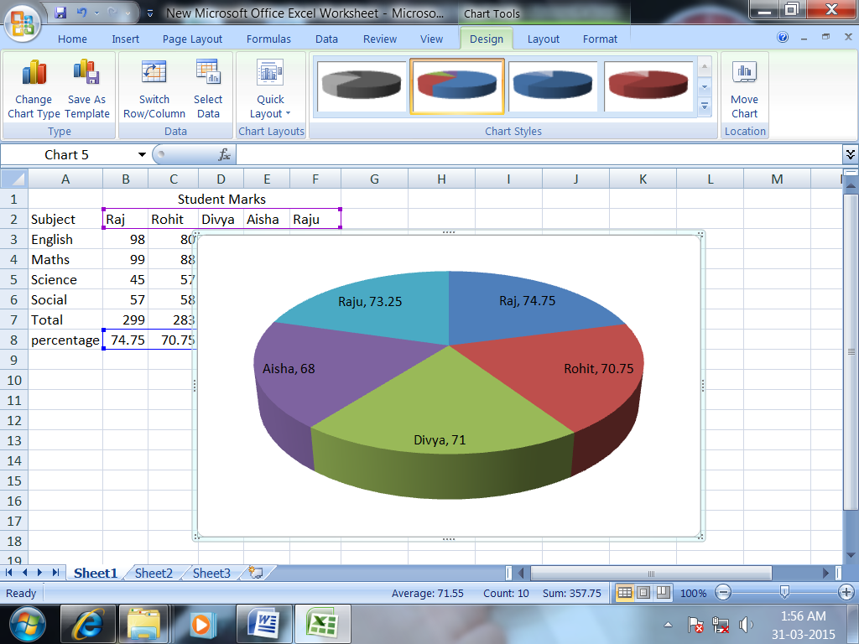

- AIM:- To Format a Worksheet In Excel , Page Setup and Print
Procedure:-
- Click on Start Button
- Click on All Programs
- Select Ms office and click on MS Excel 2007
- Excel sheet will be open with rows and columns called cell
- Point the cursor on the cell and Enter data in the cell
- Click on office button from top left corner of the window and click on Print
- Select Print Preview and click on page setup set the page, margins, header/ Footer and sheet then click on print

MS PowerPoint 2007
PowerPoint is currently the most common Microsoft office software package used for making visual aids for presentations. It has been redesigned for the 2007 release with a much more user-friendly and intuitive layout. Microsoft power point is a popular application for creating dynamic presentations. Presentations created with in power point can contain text, graphics, audio, video and more.

Basic Tips
- It is best to outline your entire presentation before working too much on the style and layout of your presentation. When left to the end it is much less time consuming to work on the style and format of your slides. Keep in mind the content of your presentation is the most important part of it!
- Keep your points short and straightforward. Points should be complimentary to your oral presentation.
- PowerPoint allows you to add a lot of distracting sounds and excessive animations to your presentation. It is best to keep all animation as simple as possible and only use sounds if absolutely necessary.
- Stay away from unusual fonts. If you are presenting on an unfamiliar computer, the font you have chosen may not work. Arial and Times New Roman are common fonts.
- Think of contrast. If you use a dark background, use light-coloured text and vice versa. Refrain from using backgrounds that will obscure your text colour.

- AIM:- To familiarize with Ribbon Layout of MS Power point 2007
The Office Button
In the top-left corner of the new interface you will find the Office button, which replaces the File menu from previous versions of PowerPoint. Click this button to reveal options allowing you to Save and Print files. It contains a list of your most recently accessed presentations, and it contains the PowerPoint Options button, which take you to options previously found in the
Tools menu under Preferences.

The Quick Access Toolbar
Situated to the right of the Office button, the Quick Access toolbar holds buttons that can be accessed from all views of PowerPoint. Whatever you are currently doing, you will be able to access these commands. Initially, the toolbar contains a Save button and Undo and Redo buttons, but you can easily customise the Quick Access Toolbar to hold your favourite commands.

The Ribbon
The ribbon contains eight tabs, each relating to a specific task. Each tab contains several groups of tools; here the Clipboard, Slides, Font and Paragraph groups are visible. Each group contains related buttons, menus and lists. Some groups have an arrow in the bottom right corner, which gives a dialog box when clicked.

Home: Change the Font, Paragraph and Heading styles and view the clipboard and editing options

Insert:- Insert pages, tables, illustrations, links, headers, footers, text and symbols

Designs: Change page layout, choose slide themes, colors, fonts and effects, as well as background styles and graphics

Animations: Set slide transitions and custom animation for slide components

Slide Show: View entire presentation, rehearse timings, and change monitor settings for the slide show

Review:- Use proofing techniques, insert comments, track changes, compare and protect documents

View: Change document and window layout, show/hide, thumbnails, and view/record macros

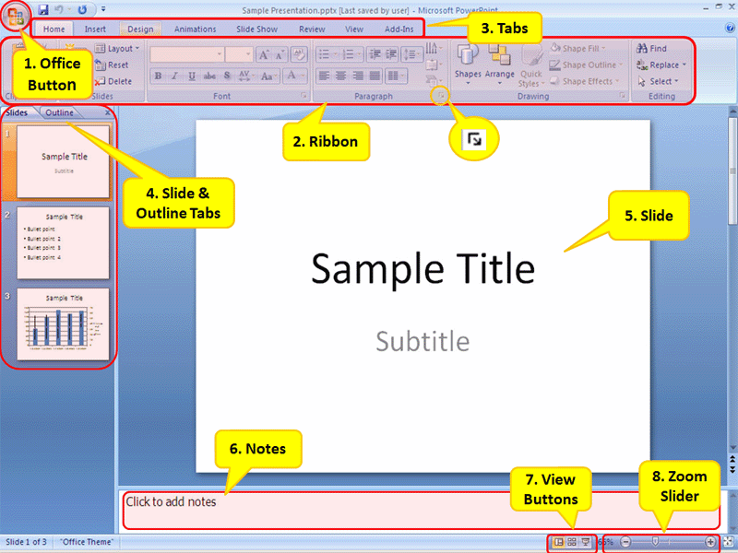

- AIM:- To create a simple power point presentations in MS Power point 2007

Procedure:-
- Click on Start Button
- Click on All Programs
- Select Ms office and click on MS power point 2007
- Click on home tab then click new slide
- A New Presentation window will appear, with Blank Presentation
- Click on the Design menu bar tab to expose the design ribbon.
- Now you may browse the Themes section and select the theme you prefer.
- Click on the Home menu bar tab to expose the ribbon.
- From the Slides section, select the slide Layout by clicking the layout dropdown menu.
Inserting Text on a Slide
- To insert text into an existing text box, by clicking in the box
- Once you can see the insertion point, you can enter, edit, and delete text within the box
- When you have finished composing text, click anywhere outside the text box to deselect it.
- If you want to add some more text then click new slide again and enter the text
- Click on office button from top left corner of the window and save the document
- To Run the presentation press F5
- Close the document by clicking on close button from top right corner of the window
Example:
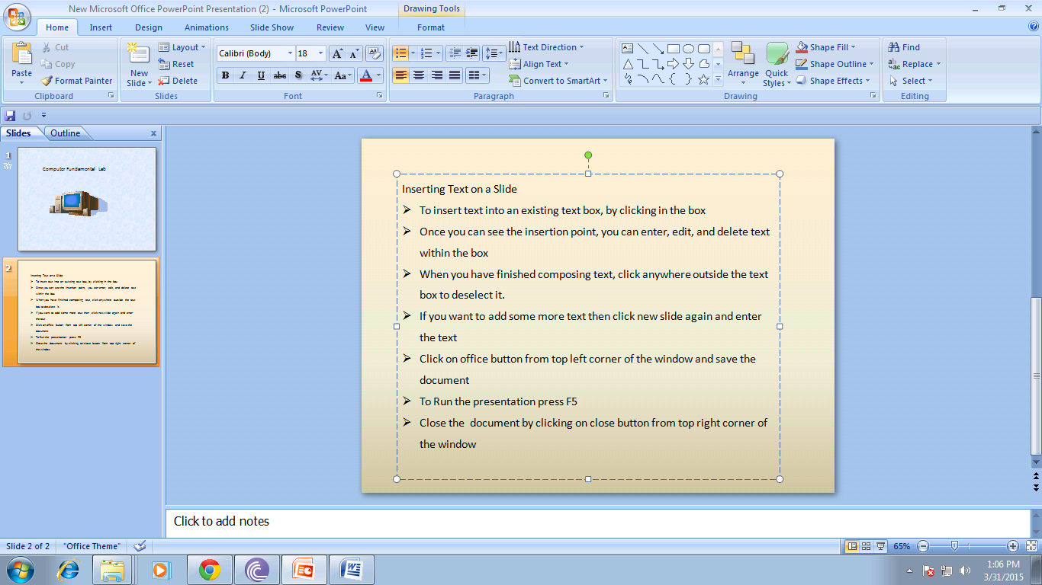

- AIM:- To set up a Master slide in MS Power point 2007

Procedure:-
- Open Microsoft PowerPoint 2007.
- In a blank presentation, click the View tab.
- Click Slide Master in the Presentation Views group.
- On the Slide Master tab, click Insert Layout in the Edit Master group.
- Click the Insert tab, and then click WordArt in the Text group.
- Insert a WordArt style of your choice.
- Click "Your Text Here" in the text box, and then type My Slide Master.
- Click the Slide Master tab, and then click Background Styles in the Background group.
- Click Colors in the Edit Theme group, and then select the theme.
- Click the Microsoft Office Button.
- Click Save As.
- Type the file name My New Slide Master.
- Select PowerPoint Template in the Save as type list, and then click Save.
- On the Slide Master tab, click Close Master View in the Close group.
Example:
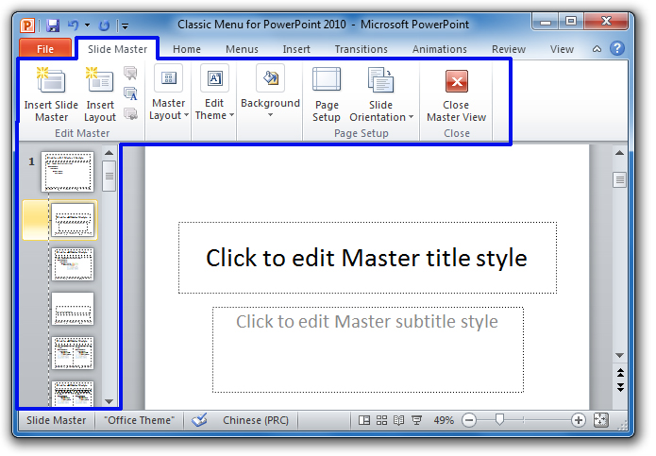

- AIM:- To insert text and objects in MS Power point 2007

Procedure:-

- Click on Start Button
- Click on All Programs
- Select Ms office and click on MS power point 2007
- Click on home tab then click new slide
- Click on insert tab and click picture window dialog box will be open
- Select picture from the window dialog box click ok.
- Click on insert tab and click text box to insert a text in the slide
- Enter the text in to the slide
- Click on office button from top left corner of the window and save the document
- Close the document by clicking on close button from top right corner of the window

Example:
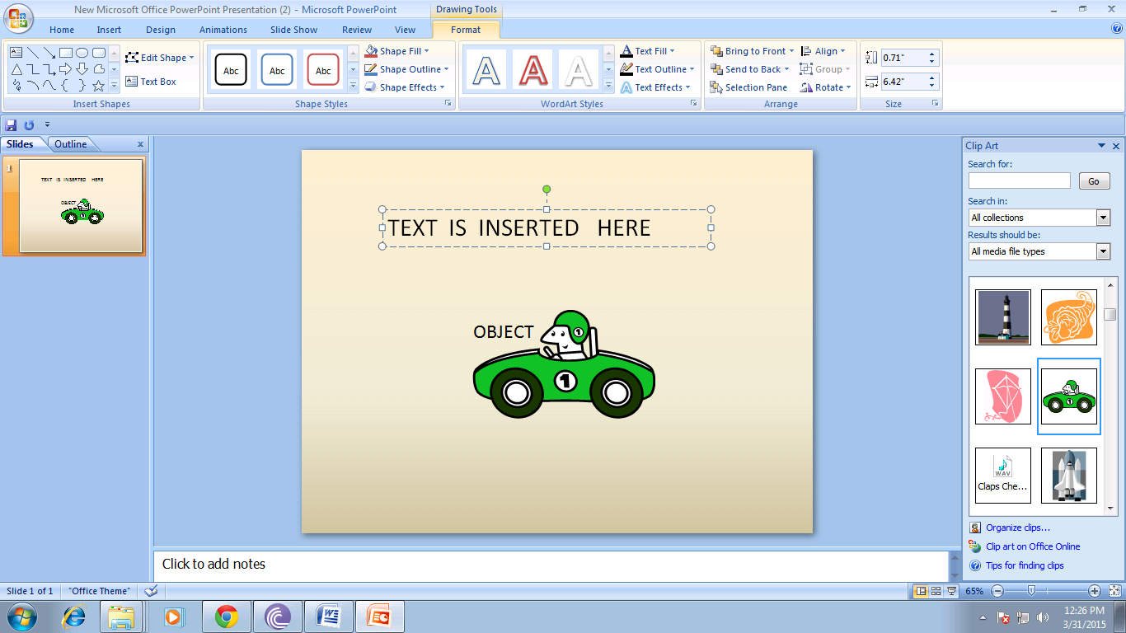

- AIM:- To insert flow charts in MS Power point 2007
Procedure:-

- Click on Start Button
- Click on All Programs
- Select MS office and click on Ms power point
- Click on home tab then click new slide
- Click on insert tab and click smart art from illustrations group
- Choose smart art graphic symbols example: hierarchy. click ok and design the flow chart in the slide
- You can also insert shapes of flow chart to design a flow chart
- Insert the data into the flow chart by clicking in the box
- Click on office button from top left corner of the window and save the document
- Close the document by clicking on close button from top right corner of the window

Example:
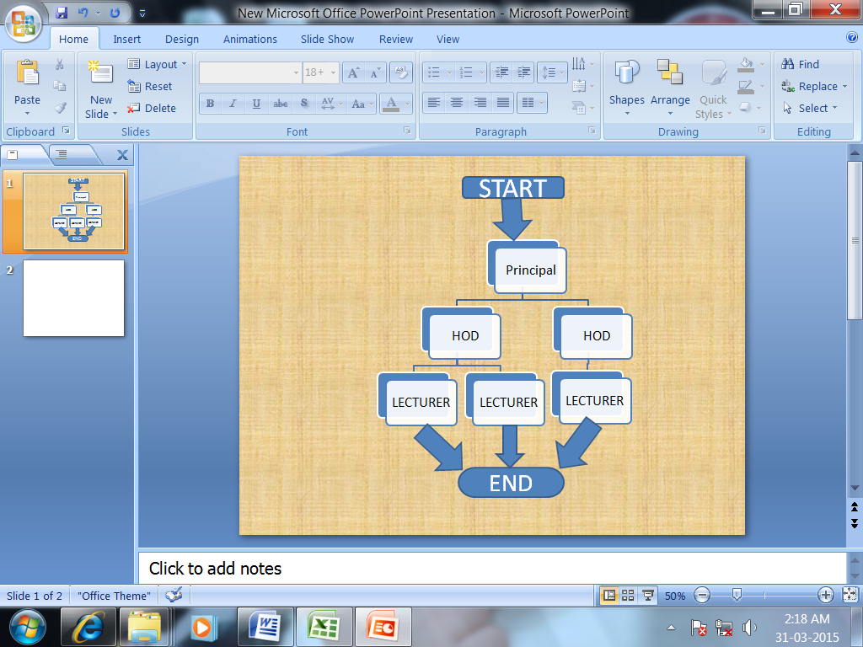

- AIM:- To Insert a Table in MS power point 2007
Procedure:-

- Click on Start Button
- Click on All Programs
- Select MS office and click on Ms power point
- Click on home tab then click new slide
- Click on insert Button
- Select table
- Click insert table from dropdown menu of table
- Select no. of rows and columns
- click ok and click in the cell insert the data
- Click on office button from top left corner of the window and save the document
- Close the document by clicking on close button from top right corner of the window

Example:
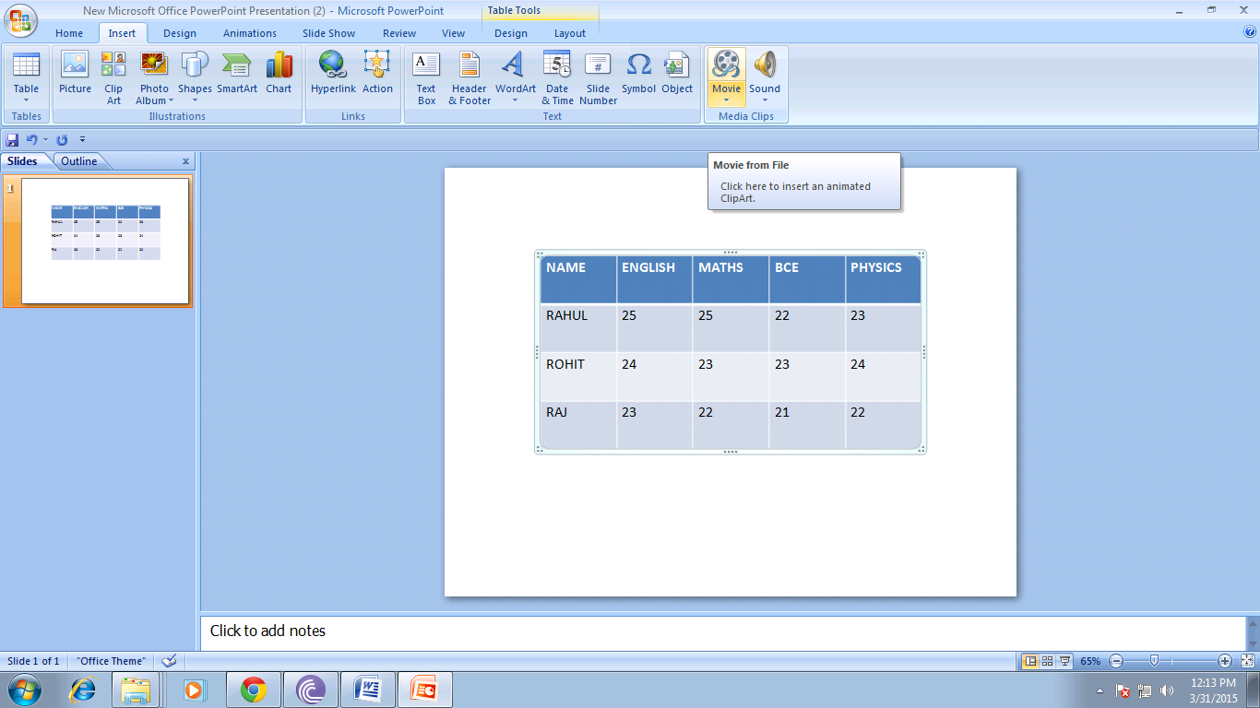

- AIM:- To insert charts/graphs in MS Power point 2007

Procedure:-

- Click on Start Button
- Click on All Programs
- Select MS office and click on Ms power point
- Click on home tab then click new slide
- Click on insert tab and click chart from illustrations group
- Select chart types like pie, bar, column etc click ok
- Automatically default chart will be inserted on the slide
- If you want to change the data on the excel sheet automatically chart reflects the changes
- If excel sheet is not displayed then click on design tab select data or edit data then change the data in excel
- Click on office button from top left corner of the window and save the document
- Close the document by clicking on close button from top right corner of the window

Example:
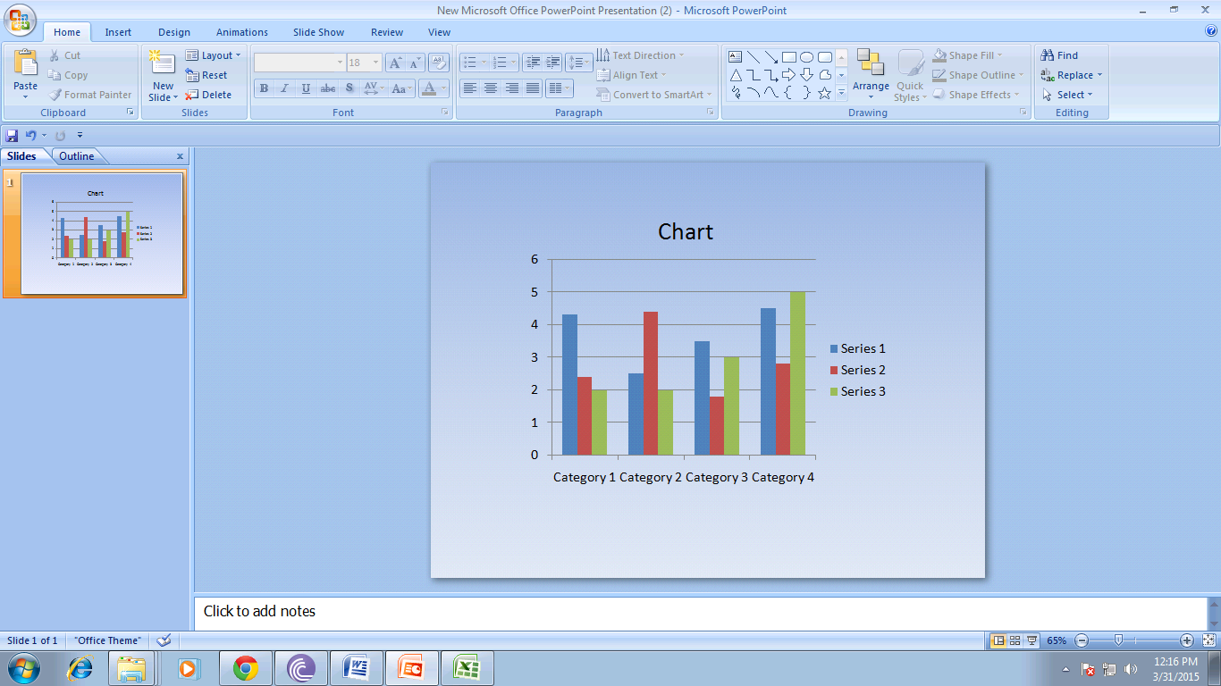

- AIM:- To insert video and audio in MS Power point 2007

Procedure:-

- Click on Start Button
- Click on All Programs
- Select MS office and click on Ms power point
- Click on home tab then click new slide
- Click on insert tab and click sound from media clips groups for audio.
- Windows gets opened browse for the file and select the file click ok
- Click on insert tab and click video from media clips groups for video.
- Windows gets opened browse for the video file and select the file click ok
- You may resize or move your movie to another location on your slide.
- To play your movie, double-click on the movie.
Or
- To run the slide show press F5
- Click on office button from top left corner of the window and save the document
- Close the document by clicking on close button from top right corner of the window

Example:
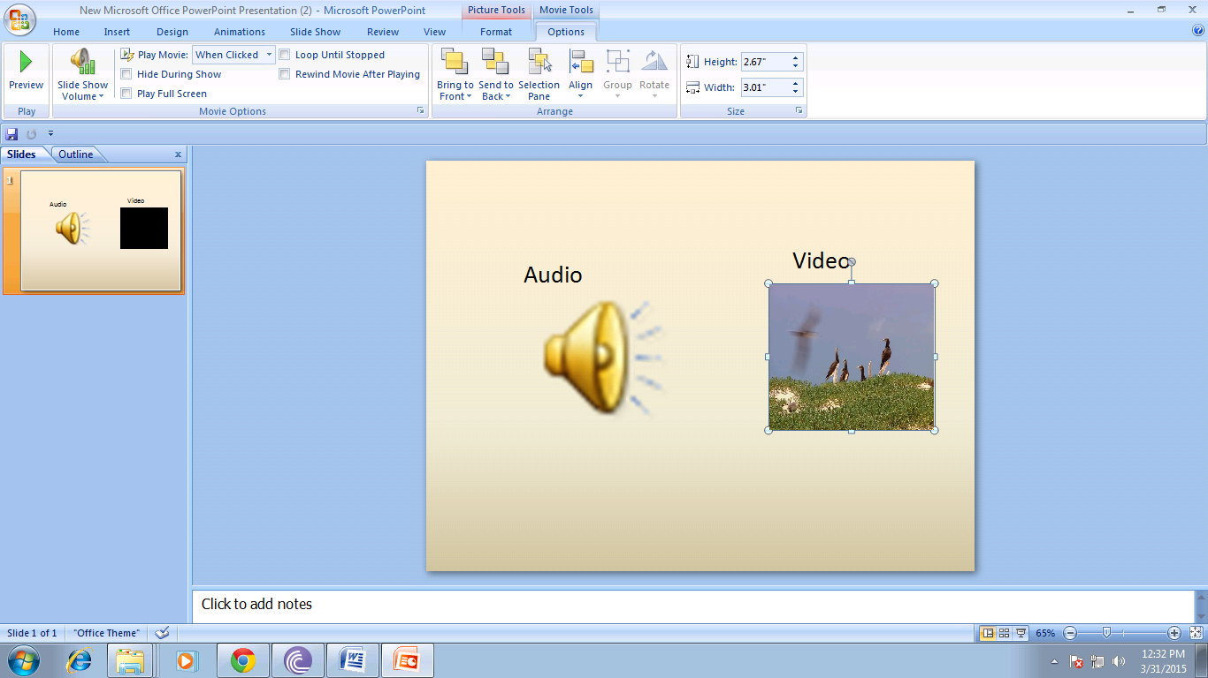

- AIM:- To practice animating text and object in MS Power point 2007

Procedure:-

- Open Microsoft PowerPoint 2007.
- In a blank presentation, insert a text of your choice (Insert > text). .
- Select the text on the slide.
- On the Animations tab, click Custom Animation to display the Custom Animation task pane.
- Click Add Effect in the Custom Animation task pane.
- Select Motion Paths > Draw Custom Path > Curve.
- Draw the animation path on the slide using your mouse pointer.
- Double-click to release the pointer and complete the motion path.
- Select the clip art image again.
- Click Add Effect in the Custom Animation pane.
- Select Motion Paths > Draw Custom Path > Scribble.
- Draw the animation path on the slide using your mouse, and then release the mouse pointer to complete the motion path.
- Click Play in the Custom Animation pane.
- Click on office button from top left corner of the window and save the document
- Close the document by clicking on close button from top right corner of the window

Example:

